***Idioms featuring animals***

*Can you work out what the idioms on the other pages mean? Try to match these phrases to the idioms.*

*Thinking about the literal meaning of the phrases might help.*

1. *to change the subject*
2. *to not get along*
3. *to have a frog in your throat*
4. *to sleep like a log*
5. *to have lots of energy*
6. *to be really hungry*
7. *to fizzle out*
8. *to have a screw loose*
9. *the weather is really bad*
10. *he’s very well known*
11. *at dusk*
12. *to stand someone up*

C:\Users\mosullivan\AppData\Local\Microsoft\Windows\Temporary Internet Files\Content.IE5\S762TUY0\MC900233594[1].wmf

finir en queue de **poisson**

C:\Users\mosullivan\AppData\Local\Microsoft\Windows\Temporary Internet Files\Content.IE5\EQOW1WGV\MC900187407[1].wmf C:\Users\mosullivan\AppData\Local\Microsoft\Windows\Temporary Internet Files\Content.IE5\EQOW1WGV\MC900366380[1].wmf

sauter du **coq** à **l’âne**

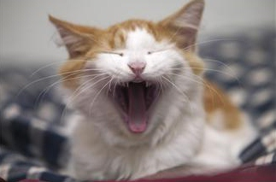

avoir un **chat** dans la gorge

C:\Users\mosullivan\AppData\Local\Microsoft\Windows\Temporary Internet Files\Content.IE5\XH8L9MQ5\MC900391558[1].wmf

dormir comme une **marmotte**

C:\Users\mosullivan\AppData\Local\Microsoft\Windows\Temporary Internet Files\Content.IE5\JH17Z1J9\MC900336251[1].wmf

il est connu comme le **loup** blanc



poser un **lapin** à quelqu’un



avoir une **araignée** au plafond

C:\Users\mosullivan\AppData\Local\Microsoft\Windows\Temporary Internet Files\Content.IE5\JH17Z1J9\MC900084414[1].wmf

entre **chien** et **loup**

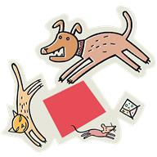

s’entendre comme **chien** et **chat**

C:\Users\mosullivan\AppData\Local\Microsoft\Windows\Temporary Internet Files\Content.IE5\VWK2O5JK\MC900216984[1].wmf

avoir une faim de **loup**

C:\Users\mosullivan\AppData\Local\Microsoft\Windows\Temporary Internet Files\Content.IE5\ZACIPG3Y\MC900417514[1].wmf

avoir mangé du **lion**

C:\Users\mosullivan\AppData\Local\Microsoft\Windows\Temporary Internet Files\Content.IE5\ZACIPG3Y\MC900411996[1].wmf

il fait un temps de **chien**